Standard Operating Procedure

This document has been written for A N Example Ltd staff. As a result, it includes A N Example Ltd-specific terms and refers to internal documents that may only be accessible to A N Example Ltd staff.

Document Name: | ANE-SOP12v1
Version: | 1
Status: | Approved
Document approved date: | 31 August 2025
Approved by: | Anne Example, Operations Manager
This SOP was last reviewed on: | 28 August 2025
Next review date: | 1 August 2026
SOP Owner: | Ted E Bear, Technical Advisor

Table of Contents
1 Introduction 3
1.1 Purpose and scope 3
1.2 Process 3
1.3 Accountability 3
1.4 Standards 4
1.5 Terminology and definitions 4
1.6 The XYZ Framework 4
2 Framework 6
2.1 Preparing Phase 6

Introduction

Purpose and scope
Lorem ipsum dolor sit amet, consectetuer adipiscing elit. Maecenas porttitor congue massa. Fusce posuere, magna sed pulvinar ultricies, purus lectus malesuada libero, sit amet commodo magna eros quis urna.
Lorem ipsum dolor sit amet, consectetuer adipiscing elit. Maecenas porttitor congue massa. Fusce posuere, magna sed pulvinar ultricies, purus lectus malesuada libero, sit amet commodo magna eros quis urna.
Nunc viverra imperdiet enim. Fusce est. Vivamus a tellus.
Pellentesque habitant morbi tristique senectus et netus et malesuada fames ac turpis egestas. Proin pharetra nonummy pede. Mauris et orci.
Aenean nec lorem. In porttitor. Donec laoreet nonummy augue.

This SOP applies to all A N Example Ltd XYZ operations:
- Lorem ipsum dolor sit amet, consectetuer adipiscing elit. Maecenas porttitor congue massa. Fusce posuere, magna sed pulvinar ultricies, purus lectus malesuada libero, sit amet commodo magna eros quis urna.
- Nunc viverra imperdiet enim. Fusce est. Vivamus a tellus.
- Pellentesque habitant morbi tristique senectus et netus et malesuada fames ac turpis egestas. Proin pharetra nonummy pede. Mauris et orci.

This SOP does not apply to:
- Lorem ipsum dolor sit amet, consectetuer adipiscing elit. Maecenas porttitor congue massa. Fusce posuere, magna sed pulvinar ultricies, purus lectus malesuada libero, sit amet commodo magna eros quis urna.
- Nunc viverra imperdiet enim. Fusce est. Vivamus a tellus.
- Pellentesque habitant morbi tristique senectus et netus et malesuada fames ac turpis egestas. Proin pharetra nonummy pede. Mauris et orci.
- Aenean nec lorem. In porttitor. Donec laoreet nonummy augue.

Process
Lorem ipsum dolor sit amet, consectetuer adipiscing elit. Maecenas porttitor congue massa. Fusce posuere, magna sed pulvinar ultricies, purus lectus malesuada libero, sit amet commodo magna eros quis urna, detailed in paragraph 1.6.
Nunc viverra imperdiet enim. Fusce est. Vivamus a tellus.
Pellentesque habitant morbi tristique senectus et netus et malesuada fames ac turpis egestas. Proin pharetra nonummy pede. Mauris et orci.

Accountability
Lorem ipsum dolor sit amet, consectetuer adipiscing elit. Maecenas porttitor congue massa. Fusce posuere, magna sed pulvinar ultricies, purus lectus malesuada libero, sit amet commodo magna eros quis urna. Nunc viverra imperdiet enim. Fusce est. Vivamus a tellus.
Lorem ipsum dolor sit amet, consectetuer adipiscing elit. Maecenas porttitor congue massa. Fusce posuere, magna sed pulvinar ultricies, purus lectus malesuada libero, sit amet commodo magna eros quis urna.
Nunc viverra imperdiet enim. Fusce est. Vivamus a tellus.
Pellentesque habitant morbi tristique senectus et netus et malesuada fames ac turpis egestas. Proin pharetra nonummy pede. Mauris et orci. Aenean nec lorem. In porttitor. Donec laoreet nonummy augue.

Standards
Lorem ipsum dolor sit amet, consectetuer adipiscing elit. Maecenas porttitor congue massa. Fusce posuere, magna sed pulvinar ultricies, purus lectus malesuada libero, sit amet commodo magna eros quis urna.
The standards meet requirements under various legislation, including the:
- 123 Regulations 2020
- ABC Act 1989
- XYZ Act 1992
Lorem ipsum dolor sit amet, consectetuer adipiscing elit. Maecenas porttitor congue massa. Fusce posuere, magna sed pulvinar ultricies, purus lectus malesuada libero, sit amet commodo magna eros quis urna.
Lorem ipsum dolor sit amet, consectetuer adipiscing elit. Maecenas porttitor congue massa. Fusce posuere, magna sed pulvinar ultricies, purus lectus malesuada libero, sit amet commodo magna eros quis urna. Nunc viverra imperdiet enim. Fusce est.
Vivamus a tellus. Pellentesque habitant morbi tristique senectus et netus et malesuada fames ac turpis egestas. Proin pharetra nonummy pede. Mauris et orci. Aenean nec lorem.
In porttitor. Donec laoreet nonummy augue. Suspendisse dui purus, scelerisque at, vulputate vitae, pretium mattis, nunc. Mauris eget neque at sem venenatis eleifend. Ut nonummy.
Fusce aliquet pede non pede. Suspendisse dapibus lorem pellentesque magna. Integer nulla. Donec blandit feugiat ligula. Donec hendrerit, felis et imperdiet euismod, purus ipsum pretium metus, in lacinia nulla nisl eget sapien.

Terminology and definitions
- Lorem ipsum dolor sit amet, consectetuer adipiscing elit.
- Maecenas porttitor congue massa.

The XYZ Framework
This framework outlines the process to follow for A N Example Ltd XYZ operations. Please refer to Figure 1 on page 3 for Framework definition.

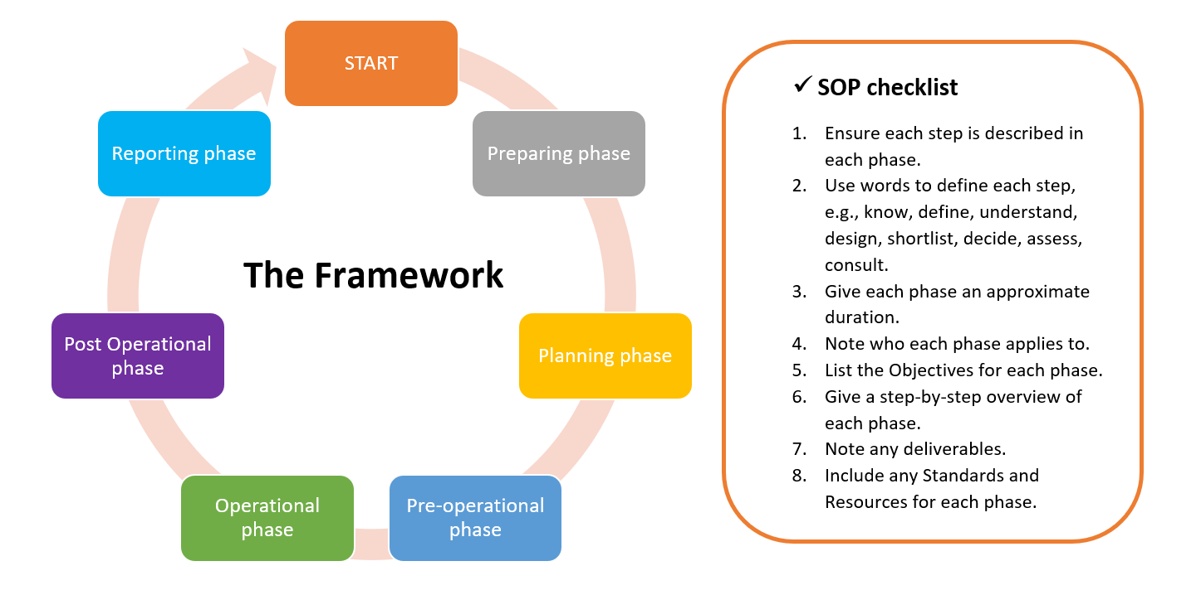
Figure 1: Framework Chart

Framework

Preparing Phase
Pellentesque habitant morbi tristique senectus et netus et malesuada fames ac turpis egestas. Proin pharetra nonummy pede. Mauris et orci. Aenean nec lorem. In porttitor. Donec laoreet nonummy augue.
Phase steps:
1. Lorem ipsum dolor sit amet, consectetuer adipiscing elit.
2. Maecenas porttitor congue massa.
3. Fusce posuere, magna sed pulvinar ultricies, purus lectus malesuada libero, sit amet commodo magna eros quis urnaetc

Preparing Phase Step 1: Background check
Time to complete: may vary depending on the number of team members assigned to this task. Please refer to Table 1 below.
Table 1: Staff Resources
No. of staff resources to this task | Time to complete
1-3 | 5 hours
3-5 | 2 hours

Applies to: all operations
Key Objectives:
- Lorem ipsum dolor sit amet, consectetuer adipiscing elit.
- Maecenas porttitor congue massa. Fusce posuere
- Magna sed pulvinar ultricies, purus lectus malesuada libero
- sit amet commodo magna eros quis urna
Process (step-by-step)
1. Donec laoreet nonummy augue
2. Pellentesque habitant morbi
3. tristique senectus et netus
4. et malesuada fames ac turpis egestas.
Standards
1. Donec laoreet nonummy augue
2. Pellentesque habitant morbi
3. tristique senectus et netus
4. et malesuada fames ac turpis egestas.
Resources
1. Donec laoreet nonummy augue
2. Pellentesque habitant morbi
3. tristique senectus et netus
Deliverable: Aenean nec lorem

Preparing Phase Step 2: Define and Document Problem
Time to complete: ½ day
Applies to: all operations
Key Objectives:
- Lorem ipsum dolor sit amet, consectetuer adipiscing elit.
- Maecenas porttitor congue massa. Fusce posuere
- Magna sed pulvinar ultricies, purus lectus malesuada libero
- sit amet commodo magna eros quis urna
Process (step-by-step)
1. Donec laoreet nonummy augue
2. Pellentesque habitant morbi
3. tristique senectus et netus
4. et malesuada fames ac turpis egestas.
Standards
1. Donec laoreet nonummy augue
2. Pellentesque habitant morbi
3. tristique senectus et netus
4. et malesuada fames ac turpis egestas.
Resources
1. Donec laoreet nonummy augue
2. Pellentesque habitant morbi
3. tristique senectus et netus
4. et malesuada fames ac turpis egestas.
5. Proin pharetra nonummy pede. Mauris et orci.
6. Aenean nec lorem. In portion.
Deliverable: Aenean nec lorem

Preparing Phase Step 3: Define and Document desired outcomes and result targets
Time to complete: ½ day
Applies to: all operations
Key Objectives:
- Lorem ipsum dolor sit amet, consectetuer adipiscing elit.
- Maecenas porttitor congue massa. Fusce posuere
- Magna sed pulvinar ultricies, purus lectus malesuada libero
- sit amet commodo magna eros quis urna
Process (step-by-step)
1. Donec laoreet nonummy augue
2. Pellentesque habitant morbi
3. tristique senectus et netus
4. et malesuada fames ac turpis egestas.
Standards
1. Donec laoreet nonummy augue
2. Pellentesque habitant morbi
3. tristique senectus et netus
Resources
1. Donec laoreet nonummy augue
2. Pellentesque habitant morbi
Deliverable: Aenean nec lorem

Preparing Phase Step 3: Decide on proposed Control methods
Time to complete: 2 days
Applies to: all operations
Key Objectives:
- Lorem ipsum dolor sit amet, consectetuer adipiscing elit.
- Maecenas porttitor congue massa. Fusce posuere
- Magna sed pulvinar ultricies, purus lectus malesuada libero
- sit amet commodo magna eros quis urna
Process (step-by-step)
1. Donec laoreet nonummy augue
2. Pellentesque habitant morbi
3. tristique senectus et netus
4. et malesuada fames ac turpis egestas.
5. Proin pharetra nonummy pede. Mauris et orci.
6. Aenean nec lorem. In portion.
Standards
1. Donec laoreet nonummy augue
2. Pellentesque habitant morbi
3. tristique senectus et netus
4. et malesuada fames ac turpis egestas.
5. Proin pharetra nonummy pede. Mauris et orci.
6. Aenean nec lorem. In portion.
Resources
1. Donec laoreet nonummy augue
2. Pellentesque habitant morbi
3. tristique senectus et netus
4. et malesuada fames ac turpis egestas.
5. Proin pharetra nonummy pede. Mauris et orci.
6. Aenean nec lorem. In portion.
Deliverable: Aenean nec lorem

